Name: **ZOHAIB HASSAN SOOMRO**

RollNo#: **19SW42**

Subject: **DBS**



1. **Character Case Conversion Example of (UPPER, LOWER, INITCAP):**

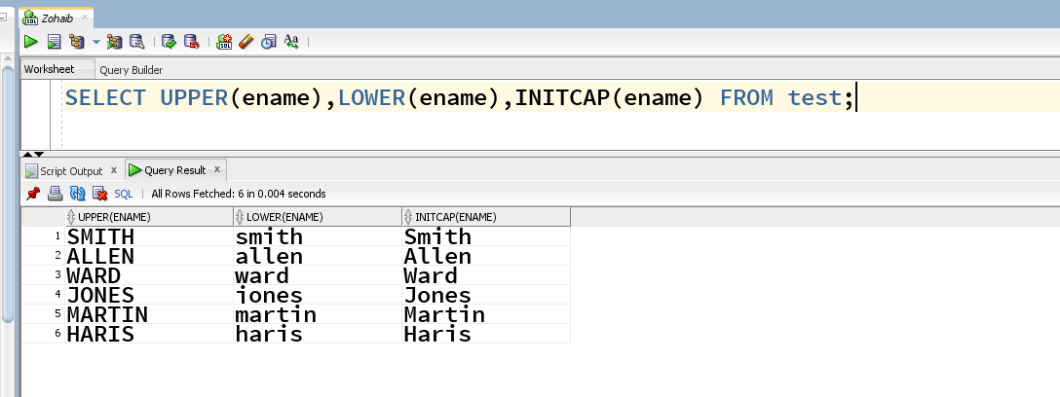

1. **Character Manipulation Example(LENGTH,LPAD,RPAD,CONCAT,REPLACE,INSTR,TRIM,SUBSTR):**

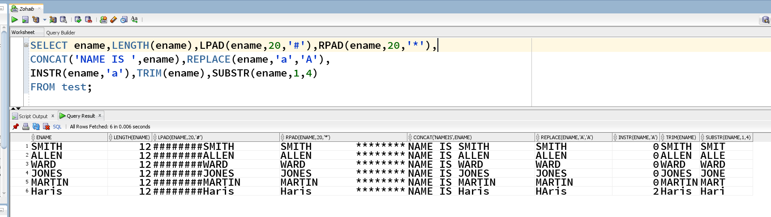

1. **General Functions Example(NVL,NVL2,NULLIF,COALESCE):**

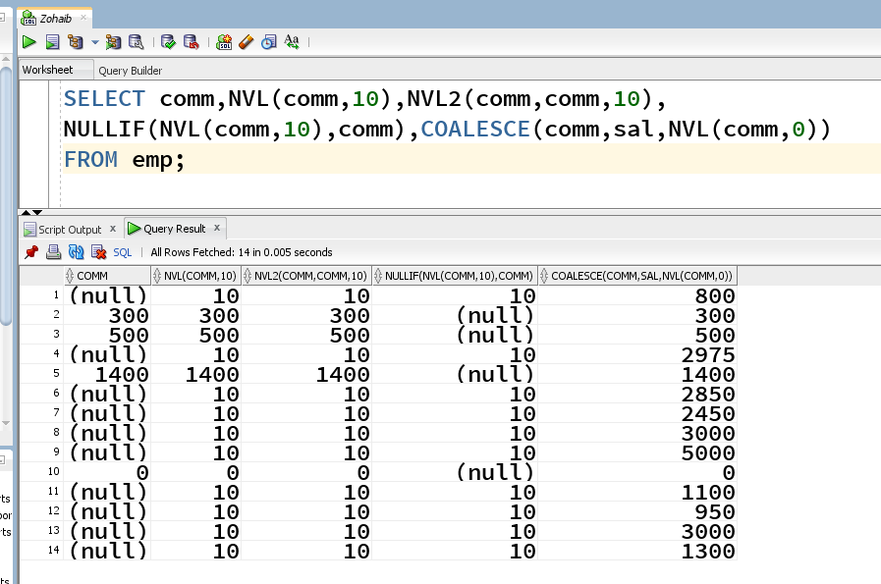

1. **DECODE FUNCTION EXAMPLE:**

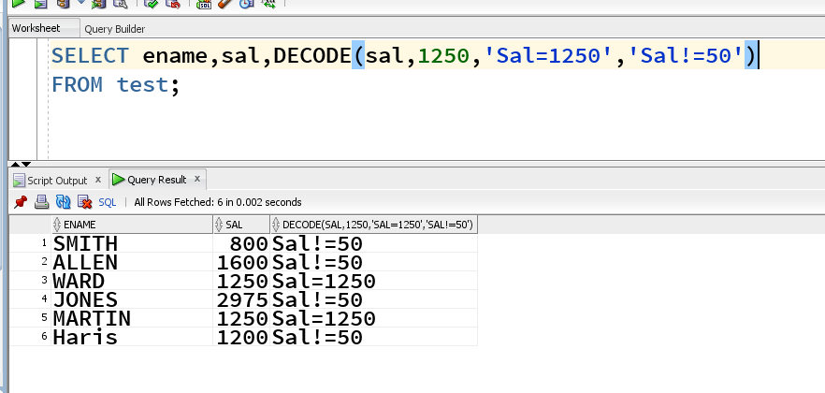

1. **NUMBER FUNCTIONS EXAMPLE(ROUND,MOD,TRUNC):**

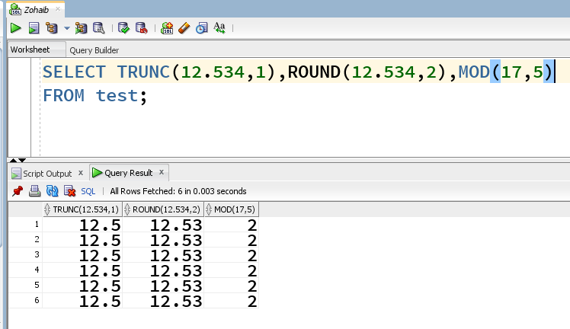

1. **DATE FUNCTIONS EXAMPLE():**

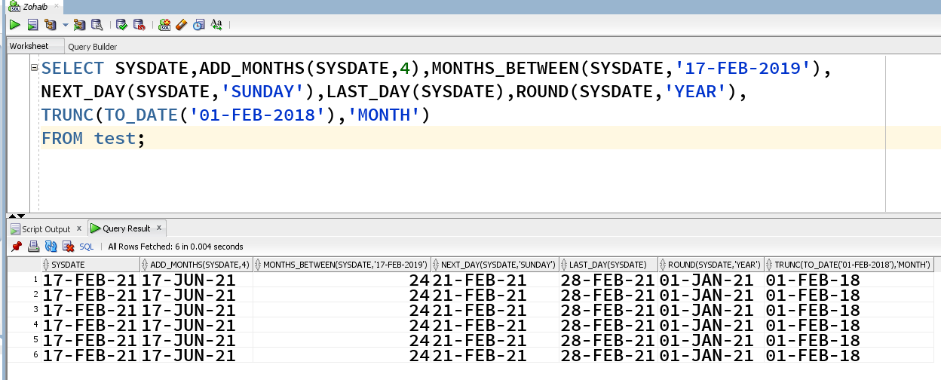

1. **CONVERSION FUNCTION EXAMPLE(TO_CHAR,TO_NUMBER,TO_DATE):**

